performance evaluation

# Profiling carried out

Here I will look at some of the different experiments I did using nsight to find where there are bottlenecks and then later on in report I will discuss why I think these bottlenecks exist.

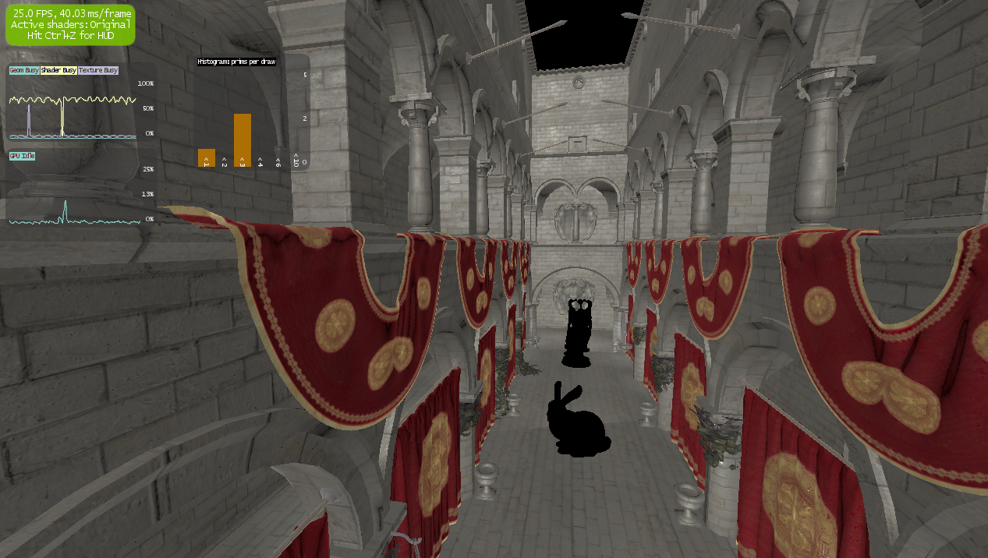

The first metric I looked at was the fps and the ms/frame, this was because it is very important to keep a good framerate as you can see on the lab machines it wasn’t actually hitting 30fps though I feel this is a problem with the Quadros not being geared toward this kind of workload. And I think the framerate could still be considered interactive. Next I had a look at the utilization of the GPU as you can see the majority of the time per frame was spent doing shading this is what I would expect as the shading is rather complex you can also see that the usage is mostly in the fragment shader.

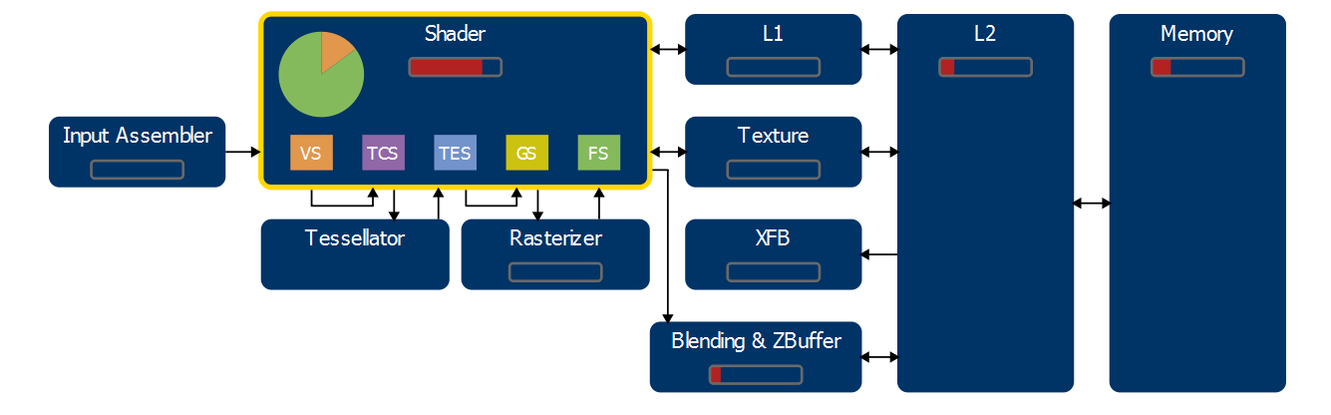

when looking at the bottleneck data we can clearly see that the shader is the main suspect as a place for optimization, and then we look at the draw calls we can see that the shader usage is only high in the last three this lines up with the lighting renders. So this lets us determine that the place to start optimizations would be in the lighting passes.

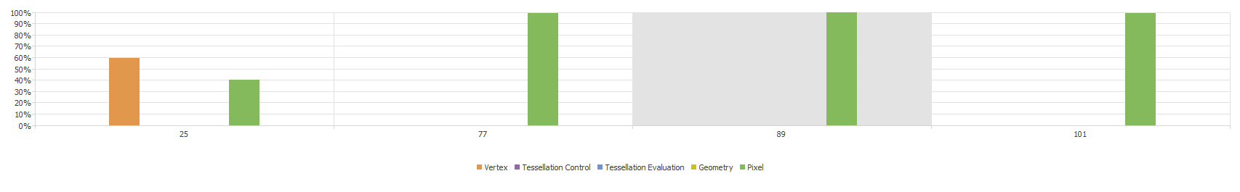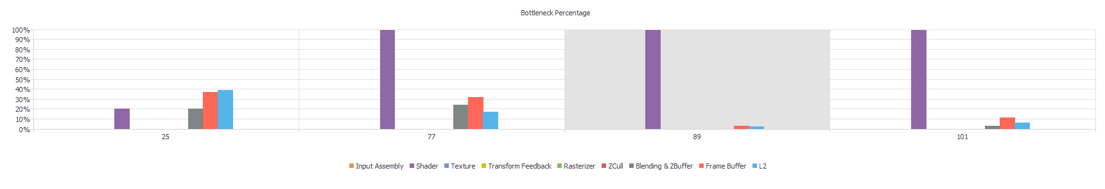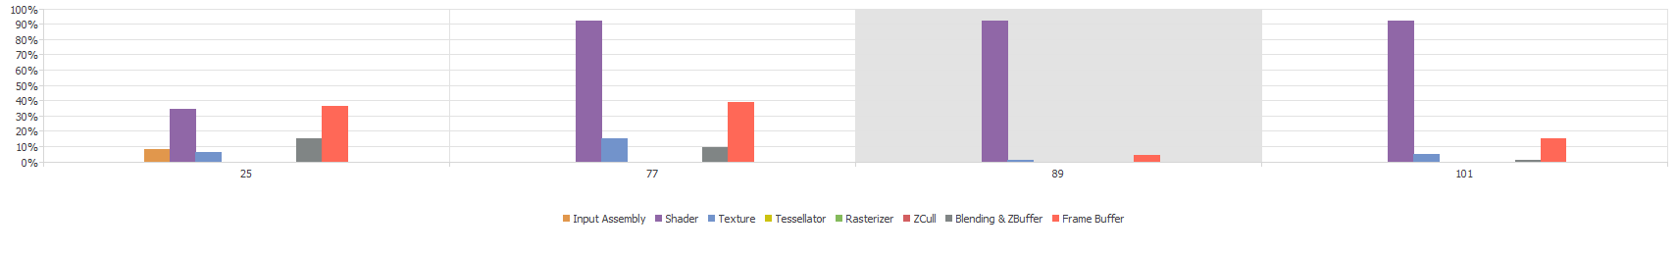

The last thing I wanted to look at was the exact shader which was causing the bottleneck as you can see except in the geometry pass the fragment shader is almost entirely the point of bottleneck. This was for the most part expected as there really isn’t a lot happening in the vertex shader on the light passes.

# HOW WOULD i combat the BOTTLENECKS?

The first thing I would look towards is precomputing the static lights within the scene as there is not really much need to compute them at runtime unless you need them to light dynamic objects in the seen, I think if it was better at the math’s involved in the PBR calculations there would be many parts of the lighting that I could simplify whilst keeping the same fidelity.

I think that rendering using the geometry may have yielded a small improvement in the labs, when I tried on my personal pc I saw a drop in fps. I’m not really sure how I could increase the fragment shader execution time for the lighting pass, one possibility is to use a less complex PBR algorithm to save on computation. I defiantly feel like there is room for optimization if I had greater knowledge.

# Conclusion

In all honesty I’m slightly disappointed with the final product think my shading looks good and the rendering of Sponza’s geometry was nice and efficient. But I couldn’t get the shadow mapping to work as I kept hitting an access violation which would crash out of sponza, given the time I had left I couldn’t give myself the time to work through the problem. I think overall I started out well but got to little done over Christmas and when I came back AGD hit be hard due to the other programmer in my group not contributing. I think I was on the right track but just ran out of time.